

**WOLKITE UNIVERSITY**

**COLLAGE OF COMPUTING AND INFORMATICS**

***DEPARTMENT OF INFORMATION SYSTEMS***

**VOICE-BASED EMAIL SYSTEM FOR VISUALLY IMPAIRED PEOPLE**

**BY: GROUP 7 STUDENTS**

**MEMBER NAMEID**

1. *NIGUS ABATE--------------------------------------CIR/141/10*
2. *EYASU AYENEKULU-----------------------------CIR/111/10*
3. *TENA DEGU---------------------------------------CIR/151/10*

***ADVISOR*** *Mr. WORKU MULUYE*

**Submission date 25/05/2021**

**Wolkite University,Wolkite, Ethiopia**

**WOLKITE UNIVERSITY**

**COLLAGE OF COMPUTING AND INFORMATICS**

***DEPARTMENT OF INFORMATION SYSTEMS***

**VOICE-BASED EMAIL SYSTEM FOR VISUALLY IMPAIRED PEOPLE**

SUBMITTED TO DEPARTMENT OF INFORMATION SYSTEM IN PARTIAL FULFILMENT OF THE REQUIREMENT FOR THE DEGREE OF BACHLER OF SCIENCE IN INFORMATION SYSTEM

BY

NAME ID

TENA DEGU-----------------------------CIR/151/10

EYASU AYENEKULU-------------------CIR/111/10

NIGUS ABATE---------------------------CIR/141/10

PROJECT ADVISOR: Mr WORKU MULUYE

**Submission date**25/05/2021

**Wolkite University, Wolkite, Ethiopia**

**DECLARATION**

This is to declare that this project work which is done under the supervision of Mr. Worku Muluye and having the title Voice based Email System for Visually Impaiered People is the sole contribution of: Tena Degu, Eyasu Ayenekulu, Nigus Abate.

No part of the project work has been reproduced illegally (copy and paste) which can be considered as Plagiarism. All referenced parts have been used to argue the idea and have been cited properly. We will be responsible and liable for any consequence if violation of this declaration is proven.

Date: _____________________

**Group Members:**

Full Name Signature

1. Tena Degu __________________
2. Eyasu Ayenekulu __________________
3. Nigus Abate __________________

**APPROVAL FORM**

This is to confirm that the project report entitled Voice Based Email System for Visually Impaired People submitted to Wolkite University, College of Computing and Informatics Department of Information System by Tena Degu, Eyasu Ayenekulu and Nigus Abate approved for submission.

**Advisor and department head Approval Form**

**Advisor Name Signature Date**

Worku Muluye **----------------- -------------------**

**Department Head Name Signature Date**

**------------------------------------------------- ------------------------------ -----------------**

**Examiner Approval Form**

Examiner Name Examiner Signature

**1.____________________________ ____________________________**

**2.____________________________ ____________________________**

**3. ____________________________ ____________________________**

# **ACKNOWLEDGEMENT**

At the outset, we thank and before GOD providing, us the ability to complete this work in this final form. Without his divine support, nothing would have been successful. We also express my deepest gratitude to our advisor, Mr Worku Muluyefor his commitment, constructive guidance, and suggestion right from the moments of problem formulation to the completion of the work. Many thanks and appreciations go to him for showing important directions, which always made us think that things are possible. We would like to thank all Information Systems Department Staff for long time experience. We would like to thank Wolkite University and all of the Computing, teachers, students and administrative staffs who have significant contributions in one way or another during our project document completion. Finally, we would like to thank my friends for their support and encouragement.

Table of Contents

**ACKNOWLEDGEMENT** i

**LIST OF TABLES** v

**LIST OF FIGURES** vi

**LIST OF ABBREVIATIONS** vii

**ABSTRACT** viii

**CHAPTER ONE** 1

**1.** **INTRODUCTION** 1

**1.1.** **Background** 2

**1.2.** **Statement of the Problem** 2

**1.3.** **The objective of the project** 2

1.3.1. General objective 2

1.3.2. Specific Objective 2

**1.4.** **Feasibility Study** 3

1.4.1. Technical Feasibility 3

1.4.2. Operational Feasibility 3

1.4.3. Economic Feasibility 3

**1.5.** **Scope of the Project** 4

1.5.1. Scope of the Project 4

**1.6.** **Significance of the Project** 4

**1.7.** **The beneficiary of the Project** 4

**1.8.** **Methodology** 5

1.8.1. Data Collection Tools/Techniques 5

1.8.2. System Analysis and Design 5

1.8.3. System Development Model 5

1.8.4. System Testing Methodology 6

1.8.5. Development Tools and Technologies 6

1.8.6. Deployment Environment 7

**1.9.** **Document Organization** 7

**CHAPTER TWO** 8

**2. DESCRIPTION OF THE EXISTING SYSTEM** 8

**2.1. Introduction of Existing System** 8

**2.2. Users of Existing System** 8

**2.3. Major functions of the Existing System** 8

**2.4. Existing System Workflow structure** 8

**2.5. Drawbacks of the Existing System** 9

**2.6. Business Rules of the Existing System** 9

**CHAPTER THREE** 10

**3. PROPOSED SYSTEM** 10

**3.1 Functional Requirements** 10

**3.2 Non-functional Requirements** 11

3.2.1 User Interface and Human Factors 11

3.2.2 Hardware Consideration 11

3.2.3 Security Issues 11

3.2.4 Performance Consideration 11

3.2.5 Error Handling and Validation 12

3.2.6 Quality Issues 12

3.2.7 Backup and Recovery 12

3.2.8 Resource Issues 12

**CHAPTER FOUR** 13

**4. SYSTEM ANALYSIS** 13

**4.1 System models** 13

4.1.1 Use Case Model 13

**4.2 Object Model** 20

4.2.1 Class Diagram 20

4.2.2 Data Dictionary 21

**4.3 Dynamic Model** 22

4.3.1 Sequence Diagram 24

4.3.2 Activity Diagram 26

4.3.3 State Chart Diagram 30

**CHAPTER FIVE** 33

**5. SYSTEM DESIGN** 33

**5.1 System Overview** 33

**5.2 Design Goals** 33

5.2.1 Performance 33

5.2.2 Dependability 33

5.2.3 Security 34

5.2.4 Maintenance 34

5.2.5 End-user 34

**5.2. Current System Architecture** 34

**5.3. Proposed System Architecture** 35

5.3.1. Subsystem Decomposition and Description 35

5.3.2. Hardware/Software Mapping 36

5.3.3 Detail Class Diagram 37

5.3.4 Persistence Data Management 38

**5.4 Algorithm Design** 38

**5.5. User Interface Design** 39

References 40

# **LIST OF TABLES**

Table 1 Use case description for Login 16

Table 2 Use case description for register information 17

Table 3 Use case description for inbox email 18

Table 4 Use case description for composing email 19

Table 5 Use case description for sent email 19

Table 6 Use case description for draft email 20

Table 7 Data dictionary for user account 23

Table 8 Data dictionary for message 23

# 

# **LIST OF FIGURES**

Figure 4.1 Use case diagram 15

Figure 4. 2 Class diagram 22

Figure 4. 3 Sequence diagram for register 24

Figure 4. 4 Sequence diagram for login 25

Figure 4. 5 Sequence diagram for composing email 25

Figure 4. 6 Sequence diagram for inbox 26

Figure 4. 7 Sequence diagram for sent 27

Figure 4. 8 Activity diagram for register 28

Figure 4. 9 Activity diagram for login 29

Figure 4. 10 Activity diagram for inbox 30

Figure 4. 11 Activity diagram for composing an email 30

Figure 4. 12 Statechart for registration 31

Figure 4. 13 Statechart for login 32

Figure 4. 14 Statechart for composing an email 33

Figure 4. 15 Statechart for inbox email 33

Figure 5. 1 Existing system architecture diagram 37

Figure 5. 2 System decomposition diagram 38

Figure 5. 3 Deployment diagram 39

Figure 5. 4 Detail class diagram 40

Figure 5. 5 Persistence diagram 41

Figure 5. 6 Home page user interface 42

Figure 5. 7 Login user interface 42

Figure 5. 9 Registration user interface 43

# **LIST OF ABBREVIATIONS**

ARPANET Advanced Research Projects Agency Network

MIT Massachusetts Institute of Technology

OOSAD Object-oriented system analysis and design

UML Unified Modelling language

VMAIL Voice mail

SMTP Simple Mail Transfer Protocol

UC Use Case

POP Post Office Protocol

IMAP Internet Massage Access Protocol

MTA Message Transfer Agent

MAA Massage Access Agent

UA User-Agent

# **ABSTRACT**

In today’s world, communication has become very easy due to the integration of communication technologies with the internet. However, visually challenged people find it very difficult to utilize this technology because using it requires visual perception.

visually challenged person can access an E-mail is, they have to speak the entire content of the mail to another person (not visually challenged) and then that second person will compose the mail and send it on the behalf of the visually challenged person or other option is using screen reader software.

This project aims at developing a voice-based email system that will help a visually impaired person to use the services by using voice. The system navigate the user on the system makes different activity by using voice.Converting user voice to text using converter perform their task on thesystem.Converting coming text into voice.

# **CHAPTER ONE**

# **INTRODUCTION**

Internet is considered a major storehouse of information in today’s world. No single work can be done without the help of it. It has even become one of the de facto methods used in communication. And out of all methods, available email is one of the most common forms of communication, especially in the business world. However, not all people can use email. This is because to access the email you would need to know what is written on the screen. If that is not visible it is difficult to use. This makes email completely useless technology for visually impaired people. As nearly 285 million people worldwide are estimated visually impaired it becomes necessary to make internet facilities for communication usable for them also.

A voice email system is a computer-based system that allows users to exchange messages without typing. These systems are designed to convert the recorded voice message into text and then it will be sent to a recipient. It is mainly useful for blind people, as every official message are only sent through the mail, they cannot type the message so our system helps them a lot [1].

## **Background**

The very first version of what would become known as email was invented in 1965 at Massachusetts Institute of Technology (MIT) as part of the university's Compatible Time-Sharing System, which allowed users to share files and messages on a central disk, logging in from remote terminals.

Text of the first email ever sent 1971. The ARPANET (a precursor to the Internet) was created “to help maintain U.S. technological superiority and guard against unforeseen technological advances by potential adversaries,” in other words, to avert the next Sputnik. Its purpose was to allow scientists to share the products of their work and to make it more likely that the work of anyone team could potentially be somewhat usable by others. One thing which was not considered particularly valuable was allowing these scientists to communicate using this network. People were already perfectly capable of communicating by phone, letter, an in-person meeting. The purpose of a computer was to do massive computation, augment our memories and empower our minds [2].

## **Statement of the Problem**

There is a special criterion for humans to access the E-mail and the criterion is you must be able to see. But some visually challenged people cannot see things. The only way by which a visually challenged person can send an E-mail is, they have to speak the entire content of the email to another person (not visually challenged) and then that second person will compose the mail and send it on the behalf of the visually challenged person and the other opition is use screen reader only text to voice. But this is not fulfil, becuas user can must write on keyboard. So this is not the right way to deal with the problem. It is very unlikely that every time a visually impaired person can find someone for help. So, for the betterment of society and giving equal status to such people we have come up with this project idea.

## **The objective of the project**

### General objective

The general objectives of this project are to develop a voice-based email system for visually impaired people.

### Specific Objective

To achieve the general objective of the project we have specifically categorized objective to meet the final goal into the following sub-divisions with some activities:

* Understand user requirement to change the current problem.
* Navigate the user on the system makes different activity by using voice.
* Converting user voice to text using converter perform their task on the system.
* Converting coming text into voice.
* The system reread the user input to correct the error by voice.

## **Feasibility Study**

### Technical Feasibility

All the resources needed for the development of the system as well as the maintenance of the system easily available.

* The system worked with current equipment and existing technology.
* The system developed through tools and devices which are currently available on the market
* The system upgraded if new technology developed.
* The needed equipment and system also easily accessed and can successfully satisfy the requirement of impaired people.

### Operational Feasibility

The proposed system is very easy for the end-user to operate. The system performs all operations to achieve the specified objective, user friendly and interactive with the user through conversation. The user can use the system without any difficulty or complex procedures to perform their operation since the proposed system performs all operations with the voice navigation. So, the project is operationally feasible.The new system enables visually impaired people to access the email facility through their voice.

### Economic Feasibility

Before the proposed system the user uses the system with the help of the second person and buy licensed screen reader due to this reason, it takes several hours and cost when we come to the proposed system the user directly communicates with the system without any time and cost loss so the proposed system is economically feasible.

**Tangible Benefits**

* It reduces the cost that pays for the second person that helps the impaired people.

**Intangible Benefits**

* It reduces time.
* Higher quality services.

## **Scope of the Project**

### Scope of the Project

The proposed system meets the needs of the user by providing the following features:

* This system focuses more on the user-friendliness or interaction of both handicaped and visually impaired people.
* The user can listen to the mail, record the mail and send the email.
* The user can replay and forward recived message.
* Attach different documents by voice.
* The system works Speech-to-Text and Text-to-Speech translation.

## **Significance of the Project**

* The use of a keyboard is partially eliminated; the user responds through voice.
* The system makes disabled people feel partially normal.
* This System easily used by users of any age group.
* People having typing problems can also take advantage of this system.

## **The beneficiary of the Project**

* Visually impaired people: - The people having sight problems can also take advantage of this system.
* The people having typing problems: - The handicapped people can also take advantage of this system.

## **Methodology**

### Data Collection Tools/Techniques

#### **Interviews**

We use face to face interviews to understand how they use email before and gather the requirement for the proposed system.

**1.8.1.2 Document Analysis**

Analysis of different document related to email system both printed and electronic (computer-based and internet transmitted) material.

### System Analysis and Design

After gathering the needed information, we used the Object-Oriented Approach for system analysis and design to examine the requirements from the perspective of the class and object found in the problem domain.

In Analysis and Design, the team members used Object-Oriented System Analysis and design (OOSAD) used Unified Modelling Language (UML) and Edraw max Software. Because of the following reason: These techniques enable to reduce the communication gap between user and designers.

* These techniques enable designers to model the real-worldentity.
* These techniques have usability features (it allows to use of codes repeatedly on other systems).
* Object-based models appeal to the workings of human cognition, and hence the human input into the development of a software system is likely to be more natural and less error-prone.
* It enables us to comprehensively model a system before we develop it
* Modification of the object implementation is easy because objects are loosely coupled.
* Direct manipulation of architectural components is possible because several object-oriented programming languages exist.

### System Development Model

There are several different software development models used in the software industry today. We developed the system by using the agile model for the following reasons:

* We work on the project in a group so agile support team collaboration.
* We can code and test the project simultaneously before designing the system requirement.
* Support quick updates and feature addition upgrade the versions of available features.

### System Testing Methodology

**Unit testing**

This is the most basic testing mechanism at the developer level. Since the designed system is in the object-oriented method the team firstly tested the system at an individual class level. This covers a very narrow and well-defined scope. We isolate the code from any outside interaction or any dependency on any module. Then the testing focuses on a very small unit of functionality. They provide a simple way to check the smallest units of code and prove that units can work perfectly in isolation.

**Integration Tests**

Integration Test forms the next class of tests at the developer level. They provide a mechanism to test the interoperation of smaller units. So, we are used this testing methodology to check whether the units are working together to achieve the project goal.

**System testing**

After all the testing performed, the system tested by a user which we are invited by the team. Especially at this level of testing the team seriously tested the system.

### Development Tools and Technologies

Software tools and techniques can be powerful aids in the design, development, testing, and maintenance of software. Several studies have reported that the application of tools and techniques result in significant benefits, including improved management control, equipment procurements that could be deferred, and reduced software costs.

#### **1.8.5.1. Front End Technology**

* **Python because: -**
* It is a great object-oriented, interpreted, and interactive programming language.
* It combines remarkable power with very clear syntax.
* The capability of interacting with almost all platforms and framework.

#### **1.8.5.2. Back End Technology**

* MySQL

#### **1.8.5.3. Hardware Requirements**

1. Pentium Core processor
2. 4GB RAM

### 1.8.6. Deployment Environment

* Our system is developed for email so it is deploying on the email server.

## **Document Organization**

**Chapter one**: this chapter deals with the identification of problems in the existing system by gathering information from the organization. Determine objective: based on the identified problem we design the general objective and specific objective of the project that we are achieving. Determine the Scope of the project.

**Chapter two**: This chapter deals with a description of the current system: we are dealing with the current system and the strength of existing systems as well as the weakness of the existing system. We identify the business rule that the existing system follows.

**Chapter three**: This chapter deals about we explain what the proposed system is and identify functional requirement, non-functional requirement, hardware and software requirement that the proposed system is to do. Determine security and safety procedures for our project.

**Chapter four**: This chapter deals about we define system analysis for our projects using the system designing the model and we use UML modelling system.

**Chapter Five**: This chapter deals about we define system design for our projects using the system designing the model and we use UML modelling system.

# **CHAPTER TWO**

# **2. DESCRIPTION OF THE EXISTING SYSTEM**

## **2.1. Introduction of Existing System**

There is a different kind of email systems which provide various facilities. But these are helpful for a limited range of users. A group of blind people are not able to use these features. These systems are only able to text convert but voice to text format and text to voice is not available.

when visually impaired people want to use the mail, they need to use the help of a second person (not visually challenged) then they have to speak the entire content of the mail to another person and then that person will compose the mail and send it on the behalf of the visually challenged person. So, the existing system may take more time to use mail.

To improve this problem, we have proposed a system that provides both facilities of voice to text and text to voice translation.

## **2.2. Users of Existing System**

Visually impaired and handicapped people use the existing system partially, the existing system does not support handicapped and visually challenged people instead of more suitable for the normal user (not visually challenged).

## **2.3. Major functions of the Existing System**

The major function of the current system:

* Normal users (not visually challenged) can compose, sent and receive mail.
* The existing system uses SMTP protocol that allows the normal user to transmit the message from the outgoing server to the receiver.
* The current system popular method for document sharing within companies.
* The existing system makes able the user dealing business activities.

## **2.4. Existing System Workflow structure**

* + User must have register first then login to the system.
  + User Click new or compose.
  + Then enter the intended recipient's email addresses in the field.
  + After this user writes a suitable subject in the Subject field then.
  + Write the message in the space below the Subject field.
  + The user clicks send button to send the email.

## **2.5. Drawbacks of the Existing System**

The existing system does not have a platform that support the impaired people. The only way which a visually challenged person can send an E-mail is, they have to speak the another person (not visually challenged) and then that second person will compose the mail and send it on the behalf of the visually challenged person.

## **2.6. Business Rules of the Existing System**

* Draft a clear, simple subject line.
* Use a standard font.
* Address your recipient formally.
* Structure your message.
* Include a professional closing.
* Proof read your email carefully.

# **CHAPTER THREE**

# **3. PROPOSED SYSTEM**

The existing email system does not provide any access facilities to visually impaired person,becuas have not a platform that help blind [3]. The proposed system was an alternative to the existing system which has more features including voice to text and text to voice translation. The current system focuses only on a particular set of people, but our system is focused on too visually challenged people.

This system based on voice or speech. The user was able to give commands to the system, which, the system followed. Moreover, the system prompts the user to perform specific actions to avail of respective services. The system accessed by all computing devices that have micraphone.The proposed system focuses on reliability and user interaction. This system is helpful for visually impaired people.

## **3.1 Functional Requirements**

A functional requirement is an area of functionality that the system must support.

* User
* Register and login to the system.
* Send the email to the recipient by voice.
* Listen to the email that recived from the sender and replay them using a text converter.
* Manage their account reset and change their password.
* Delete unwanted email from the system.
* Forward the email using the system.
* Recover the email delete suddenly in trash.
* Attach a file by voice.
* Keep a file using spam.
* System Administrator
* Manage all the account of the users.

## **3.2 Non-functional Requirements**

### 3.2.1 User Interface and Human Factors

This accessibility achieved through using the user email and password. The dialogue with the system is easy to follow due to the user-interaction which is very easy to communicate and the system can navigate its way through voice. The system provides an interactive and easily manageable user interfacve for the users.

### 3.2.2 Hardware Consideration

The system works on any computer device that has a microphone or stereo mix that used to input speech from the user and output voice.

### 3.2.3 Security Issues

The system has a login page it allows only the user who has the privilege to access the system, therefore, the system can’t be accessed by an unauthorized user. When the user wants to access the system, they need to sign up to the system and sign in to the system by voice.

The system applied security mechanisms in which users can only access information and perform any operation through their own authorize. Only authenticated users can access the system.

* Only assigned users can use the system for the sake of privacy & to increase reliability.
* Only authorized user is authenticated to user name and password.
* Use a headephone listen to email.
* Put neccessery file in spam.

### 3.2.4 Performance Consideration

Performance: Since the system is accessed by different users with different needs, capable of handling and processing their queries quickly. The proposed system performs its operations within a minimum amount of time and the user gets the expected result within a few seconds and the system is effective.

* Response time upon request for user in speech command the system under normal condition should display results as quickly as possible.
* Processing time since the system is developed with efficient programming language and database upon request for users’ activities the system under normal condition should `process the request as quickly as possible.

### 3.2.5 Error Handling and Validation

If an error occurs, the system identifies the error and notify the user so that he/she can take the appropriate corrections rather than terminating the system and the system must handle the error for instance if a login error occurs: the system handling an attempt to login with incorrect username and password and provide alert error message by voice.

### 3.2.6 Quality Issues

The system is functional at any time. There is no delay in the availability of any information, whatever needed. The system supports the use of multiple users at a time.

### 3.2.7 Backup and Recovery

For backup and recovery, we need another server and cloud to store the system file. If the data is failed or lost, then the lost data can be easily recovered.

### 3.2.8 Resource Issues

Use this constraint:

* A proper headphone is to be used.
* Working with a microphone or stereo mix.

.

# **CHAPTER FOUR**

# **4. SYSTEM ANALYSIS**

This chapter deals with techniques applied in information system analysis, data modelling. This chapter shows a process of providing a full specification of systems to users to help them consider and accept. This specification is also a major information source for designers of the new system. It not only specifies the system's objectives but also describes the work and its constraints to which designers have to comply.

System Analysis is the process of gathering and interpreting facts, diagnosing problems, and using the information to recommend improvements to the system.

## **4.1 System models**

The goal of the analysis phase is to truly understand the requirements of the new system and develop a system that addresses them or decide a new system is not needed. Systems analysis incorporates initial systems design. A system model is a conceptual model that describes and represents a system.

### 4.1.1 Use Case Model

A system use case model is composed of use case diagram associations. An important goal of requirements modelling is to come to an understanding of the business problem that your system is to address to understand its usage requirements. Use case models to focus on exactly this issue.

#### **4.1.1.1 Use case diagram**

Use Case represents an interaction between the user and the system. So, when the requirements of a system are analysed, the functionalities are captured in use cases.

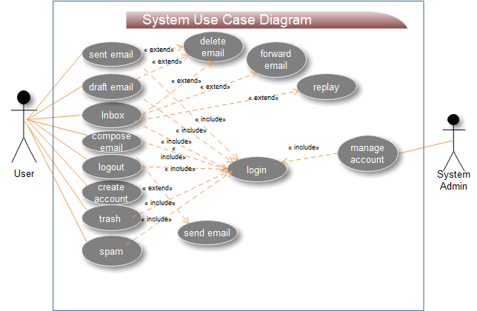

Figure 4. 1 Use case diagram

**4.1.1.2 Use case description**

Describing each use case process helps to clarify the concept of the use case and list the components of our project step-by-step.

|  |  |  |
| --- | --- | --- |
| Use case name | Login | |
| Use case number | UC-01 | |
| Participation actor | User | |
| Pre-conditions | The user must have a valid email and password | |
| Description | When the user enters email and password, it checks the inputs from the database. If it is valid, it allows the user to access and if not it'sread error message. | |
| Basic course of action | User said:  Step2: user select login  Step4: user inter by voice email and password  Step6: if the user says ok | System said:  step1: the system gives a choice  step3: system display login form and say inter email and password  step5: system read the entered value to check correctness. if correct say ok if incorrect say no.  step7: the system allows the user to login |
| An alternative course of action | If the user says no  System clean entered value and say please enter correct email and password | |
| Post-conditions | Go to the page and perform their task | |

Table 1 Use case description for Login

|  |  |  |
| --- | --- | --- |
| Use case name | Register information | |
| Use case number | UC-02 | |
| Participation actor | User | |
| Pre-conditions | The users must fill the correct information | |
| Description | When the user enters the full necessary information, it puts it in the database. If it is valid, save it and allows the user to login and if not,it read an error message. | |
| Basic course of action | User said:  Step2: user select Register  Step4: user entered by voice full information  Step6: if the user says ok | System said:  step1: the system gives a choice  step3: system display register form and say enter your information  step5: system read entered value for check correctness if correct say ok if incorrect say no  step7: the system registers users |
| An alternative course of action | If the user says no  System clean entered value and say please enter correct full information | |
| Post-conditions | The user hears you have registered successfully messageand the system turn on the first page | |

Table 2 Use case description for register information

|  |  |  |
| --- | --- | --- |
| Use case name | Inbox mail | |
| Use case number | UC-03 | |
| Participation actor | User | |
| Pre-conditions | The users should login to the system | |
| Description | When the user chooses inbox, the system has to display and count unread message. | |
| Basic course of action | User said:  Step2: user select inbox email  Step4: user choose one of them  Step6: if the user says back to yes | System said:  step1: the system gives a choice  step3: system displayed inbox content and count unread message  step5: system open inbox information and read  step6: after reading the system gives a choice back to dashboard say no or read more say yes  step7: the system back to the inbox and count again |
| An alternative course of action | If the user says no System back to the home page | |
| Post-conditions | The user listensthe received message | |

Table 3 Use case description for inbox email

|  |  |  |
| --- | --- | --- |
| Use case name | compose email | |
| Use case number | UC-04 | |
| Participation actor | User | |
| Pre-conditions | The users should have login | |
| Description | When the user enters full necessary information and attaches it to the recipient | |
| Basic course of action | User said:  Step2: user select compose an email  Step4: user entered by voice full information  Step6: if the user says ok | System said:  step1: the system gives a choice  step3: system display attachment content and say enter all label  step5: system read entered value to check correctness if it is correct to say ok if not say no  step7: the system sends to the recipient |
| An alternative course of action | If the user says no  The system can say the message not sent | |
| Post-conditions | The system says the message is sent successfully and back to the homepage. | |

Table 4 Use case description for composingan email

|  |  |  |
| --- | --- | --- |
| Use case name | sent email | |
| Use case number | UC-05 | |
| Participation actor | User | |
| Pre-conditions | The users should have login | |
| Description | When the user selectsthe sent box the system count sentan email to the recipient | |
| Basic course of action | User said:  Step2: user select sent box  Step6: if the user says ok | System said:  step1: the system gives a choice  step3: system display sent box content and count send message  step4: system give choice back to homepage say yes or read more say no  step7: the system back to the home |
| An alternative course of action | If the user says no  The system gives a choice | |
| Post-conditions | The system read sent message and back to the homepage. | |

Table 5 Use case description for sent email

|  |  |  |
| --- | --- | --- |
| Use case name | Draft email | |
| Use case number | UC-06 | |
| Participation actor | User | |
| Pre-conditions | The users should have login | |
| Description | The user viewsan unsent message | |
| Basic course of action | User said:  Step2: user select draft email  Step5: if the user says ok | System said:  step1: the system gives a choice  step3: system display draft box content and count them  step4: system gives choice back to homepage say yes or read more say no  step7: the system back to the home |
| An alternative course of action | If the user says no  The system says choose more read | |
| Post-conditions | Reads unsent messageand back to the homepage. | |

Table 6 Use case description for draft email

#### **4.1.1.3 Use case scenario**

**Use Case Scenario for login**

Participant actor: User

Mr X wants to login to the system first to run the system then the system displays the home page next Mr X choose the login link from the home page. After that the system display login form then Mr X fill login form and say ok then dashboard is displayed after that Mr X can send, read, delete, logout and work other activity.

**Use Case Scenario for Register**

Participant actor: User

Mr X wants to register to the system first run the system then the system displays the home page next Mr X choose register link from the home page. After that the system displays the registration form then Mr X fill the registration form and say ok finally the account is created into a database.

## **4.2 Object Model**

The object model is a description of an object-oriented architecture, including the details of the object structure, interfaces between objects and other object-oriented features and functions.

### 4.2.1 Class Diagram

Class diagrams can be derived from use-case diagrams or data dictionary. A class diagram is generated by system analysts and designers and will be iteratively refined in the subsequent phases during the software development life cycle. Describing what exists and what attributes and behaviour it has, rather than how something is done. Class diagrams are most useful to illustrate relationships between classes and interfaces. The purpose of a class diagram is to depict the classes with a model.

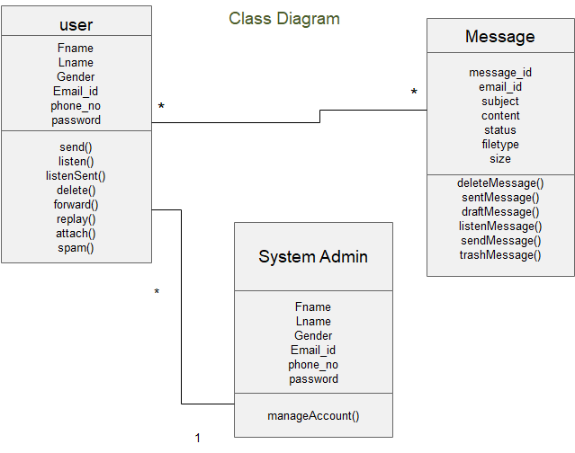

Figure 4. 2 Class diagram

### 4.2.2 Data Dictionary

This section mention attributes, data type, data size, key constraints and constraints on the identified entities or classes by using a tabular form.

|  |  |  |  |  |  |  |  |
| --- | --- | --- | --- | --- | --- | --- | --- |
| Table name | Key type | Attribute | Description | Field name | Data type | Validation rule | Size |
| User |  | First Name | User first name for registration | F_name | Varchar | Not null | 20 |
| Last Name | User last name for registration | L_name | Varchar | Not null | 20 |
| Gender | The genders of the student | Gender | Varchar | Not null | 10 |
| Primary key | Email | Email id for register and login | Email_id | Varchar | Not null | 20 |
|  | Phone number | User phone number | Phone_no | Integer | Not null | 15 |
| Password | User password | Password | Varchar | Not null | 20 |

Table 7 Data dictionary for user account

|  |  |  |  |  |  |  |
| --- | --- | --- | --- | --- | --- | --- |
| Table name | Attribute | Description | Field name | Data type | Validation rule | Size |
| Message | Meesage_id | Represent messages | Message_id | Varchar | Not null | 20 |
| Email_id | Contain sender email | Email_id | Varchar | Not null | 20 |
| Subject | Title of email | subject | Varchar | Not null | 100 |
| Content | The received file | content | Varchar | Not null | 1000 |
| Status | Date and time of the received message | status | Varchar | Not null | 20 |
| File type | File format | filetype | Varchar | Not null | 20 |
| Size | The size of a received message | size | Varchar | Not null | 20 |

Table 8 Data dictionary for message

## **4.3 Dynamic Model**

The dynamic model represents the time-dependent aspects of a system. It is concerned with the temporal changes in the states of the objects in a system. In this section, we describe the behaviour of the object model, in terms of sequence, activity and state chart diagrams.

**4.3.1 Sequence Diagram**

Describe the flow of messages, events, and actions between objects. It shows concurrent processes, activations and time sequences that are not easily depicted in other diagrams.

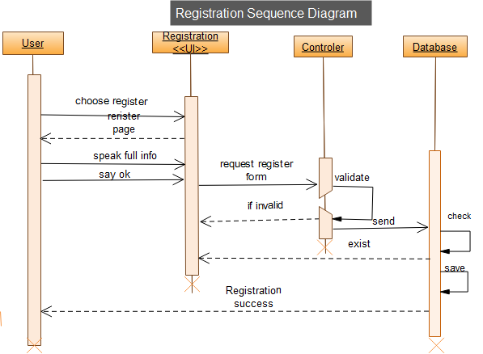

Figure 4. 3 Sequence diagram for register

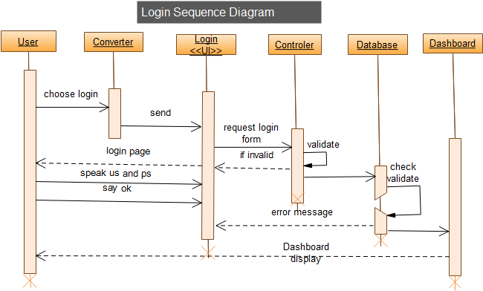

Figure 4. 4 Sequence diagram for login

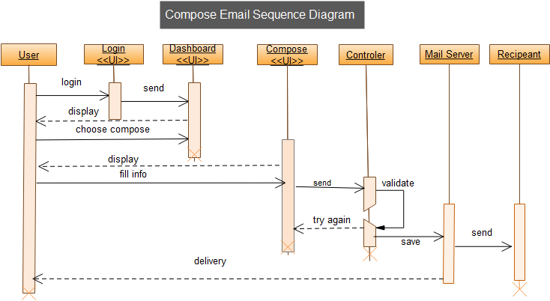

Figure 4. 5 Sequence diagram for composingan email

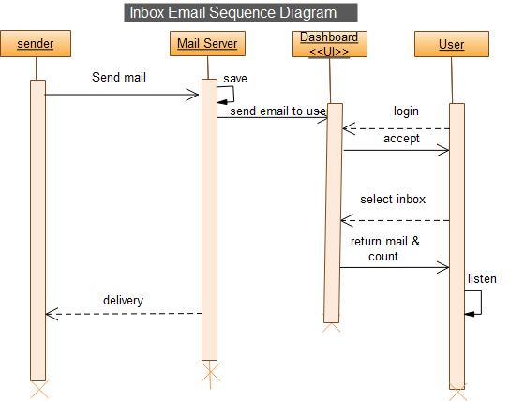

Figure 4. 6 Sequence diagram for read email

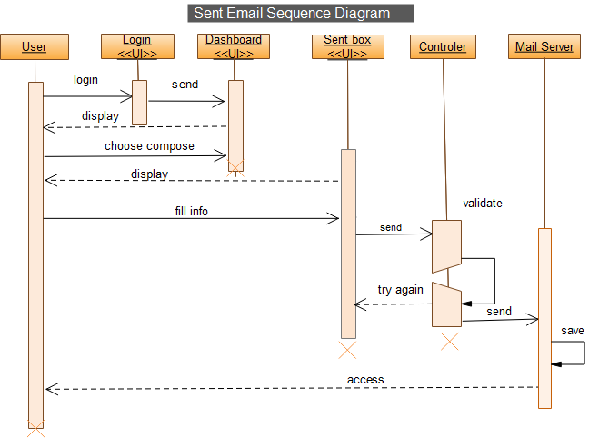

Figure 4. 7 Sequence diagram for sent

### 4.3.2 Activity Diagram

This diagram is useful in showing workflow connections and describing behaviour that has a lot of parallel processing. When you use an activity diagram you can choose the order in which to do things. It states the essential sequence rule to follow.

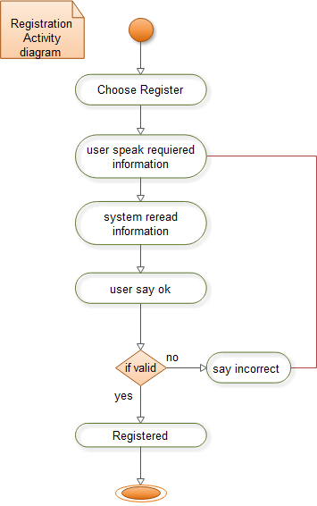

Figure 4. 8 Activity diagram for register

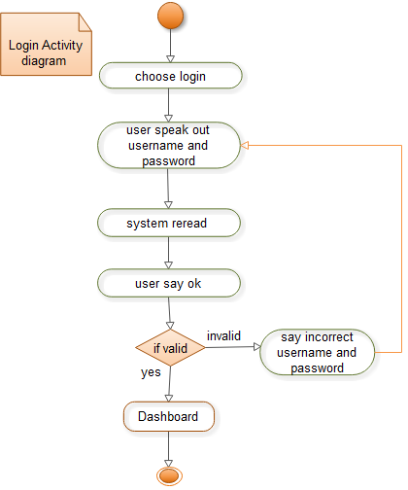

Figure 4. 9 Activity diagram for login

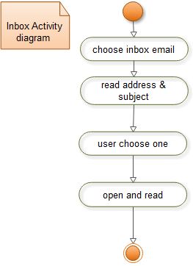

Figure 4. 10 Activity diagram for inbox

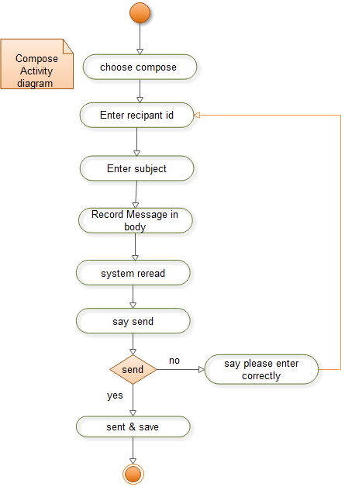

Figure 4. 11 Activity diagram for composing an email

### 4.3.3 State Chart Diagram

It shows the sequences of states that an object or an interaction goes through during its life in response to received stimuli, together with its responses and actions.

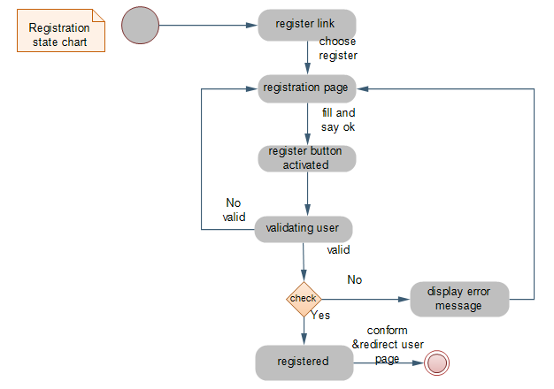

Figure 4. 12 Statechart for registration

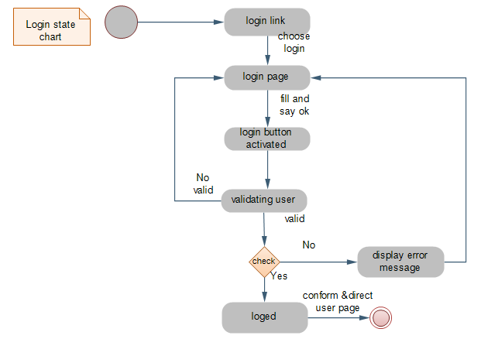

Figure 4. 13 Statechart for login

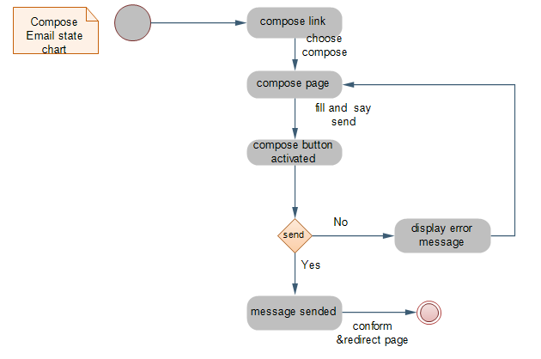

Figure 4. 14 Statechart for composing an email

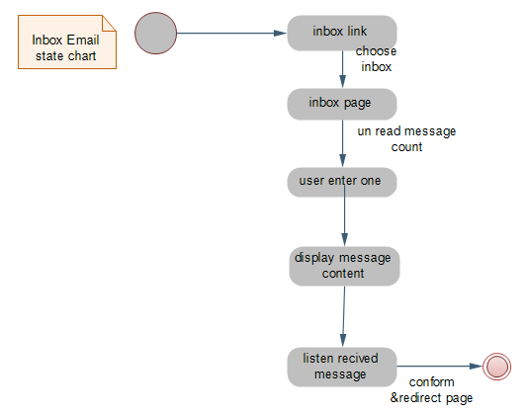

Figure 4. 15 Statechart for inbox email

# **CHAPTER FIVE**

# **5. SYSTEM DESIGN**

## **5.1 System Overview**

This chapter describes the result of the design of the system carried out during the design phase of Voice based email system. The first section describes the desirable design goal that the system strives to achieve and describing the quality of the system that we shall use to optimize derived from non-functional requirements.

The design goal is stated clearly in such a way that making design decisions will be in light of these goals. The second section which is the most important one describes the system under development in terms of system decomposition, system architecture, deployment diagram, and persistence modelling for the object-oriented database system and access control.

## **5.2 Design Goals**

The design goals represent the desired qualities that the system should have and provide a consistent set of criteria that would be taken into consideration when making design decisions. The following are outlined to be the design goals of Voice based email system for visually impaired people.

### 5.2.1 Performance

To the Voice based email system able to communicate easily. The system should meet the following performance criteria’s Response time: The system should provide immediate feedback to the user action.Throughput: number of tasks accomplished in a fixed period.Memory: memory space available for speed optimizations should use efficiently.

### 5.2.2 Dependability

The Voice based email system should achieve the following dependability characteristics

Robustness: - when an error occurs during the process of entering data. At this time the system will provide an error message and the system will continue without failure or crush.

Availability: -As long as there is an internet connection the system will be available always.

Security-: The system is secured, i.e.,the system does not allow unauthorized users to access the system.

### 5.2.3 Security

To access the system, the user should have an account. The system is highly secured by using User Email and Password. Unauthorized access to the system, by any means, should be restricted.

### 5.2.4 Maintenance

In a time of failure or need modification the system, need to maintain. To be maintainable the system should meet the following maintenance criteria.

Extensibility: - if it needed to add new functionality to the system, this must-have achieved by only making a separate page and integrate this page with the existing system.

Modifiability: - if in the system, some functionality requires to be modified, this modification must be done specifically to that function or page without affecting the overall system organization.

### 5.2.5 End-user

Utility: - to help the user, easily understand and interact with the system.

* Keyboard shortcut.
* By voice

Usability: - the system is an easy and user-friendly system. For impaired people. user can access it simply by using voice. The system should be designed incorporating the following usability concepts:

* Consistent page pattern.
* Less overcrowded interface

## **5.2. Current System Architecture**

The main components of e-mail system architecture that facilitate sending and receiving of e-mail on the internet are:

* An e-mail client
* An e-mail server
* Some protocols like SMTP (Simple Mail Transfer Protocol), POP (Post OfficeProtocol), IMAP (Internet Massage Access Protocol)

For transferring an e-mail from one user to another first the massage/mail goes to the user agent (UA) which provides services to make the process of sending and receiving the e-mail easy on both ends then the message/mail is composed and sent to Message Transfer Agent (MTA), it follows some protocols for travelling from one server to other over the internet which is SMTP (Simple Mail Transfer Protocol), POP (Post Office Protocol {nowadays POP3(the new version of POP)}), IMAP (Internet Massage Access Protocol) and then the message/mail is received at another terminal by Massage Access Agent (MAA) then the e-mail is further going to User Agent (UA) which receives it and provides it to end-user.

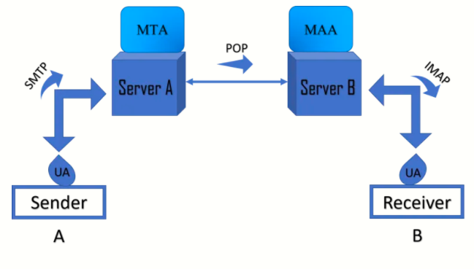

Figure 5. 1 Existing system architecture diagram

## **5.3. Proposed System Architecture**

Message Transfer from the user browser, it follows some protocols for travelling from client computer to the application server, by SMTP (Simple Mail Transfer Protocol), POP (Post Office Protocol {nowadays POP3(the new version of POP)}) between the application server and the mail server, then the message/mail is received at another terminal computer by Massage IMAP (Internet Massage Access Protocol).

### 5.3.1. Subsystem Decomposition and Description

System decomposition identifies the sub-system from the functional requirements outlined early in analysis:

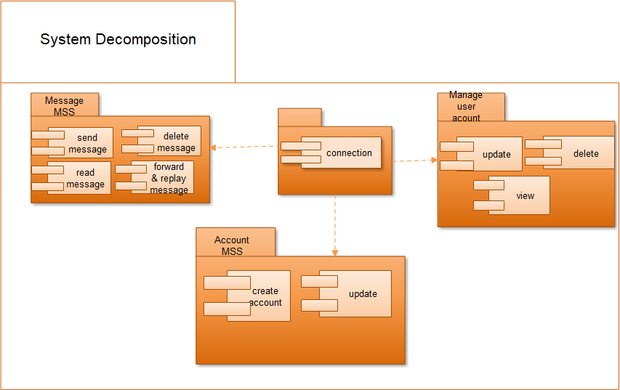

Figure 5. 2 System decomposition diagram

### 5.3.2. Hardware/Software Mapping

Deployment modelling used to show the hardware of the system, the software that is installed in the hardware and also the middleware that is used to connect the different machines to one and other. It also shows how the software and the hardware components work together.

A converter converts the user voice into text then the web browser sent a request to the application server, the application server process the received request like sent inbox delete and then access the mail server database.

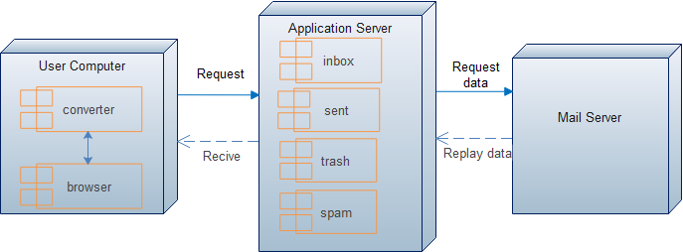

Figure 5. 3 Deployment diagram

The hardware-software mappings illustrated by the UML deployment diagram diagrammatically. Deployment diagrams show the configuration of run-time processing elements and the software components, processes, and objects that live on them. Software component instances represent a run-time manifestation of code unites.

### 5.3.3 Detail Class Diagram

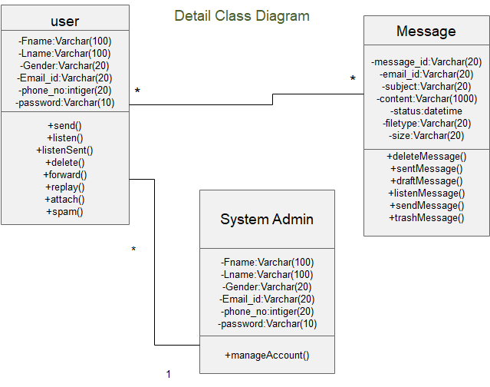

Figure 5. 4 Detail class diagram

### 5.3.4 Persistence Data Management

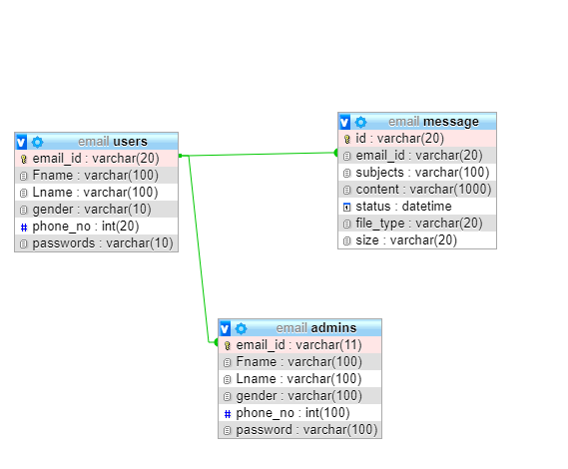

Figure 5. 5 Persistence diagram

## **5.4 Algorithm Design**

It defines the algorithm required for each element of the architectural design to accomplish its tasks.

**Pseudo code for login**

Method name: login

Begin

GET Username

GET Password

IF (Username == Entered Username && Password == Entered Password)

THEN Put cookies Login Successful

ELSE Login failed read error message.

END

## **5.5. User Interface Design**

The proposed system has a graphic user interface to interact with the user. Below the home page is visible to all user of the system. In addition, can get information notified and different links to other pages.

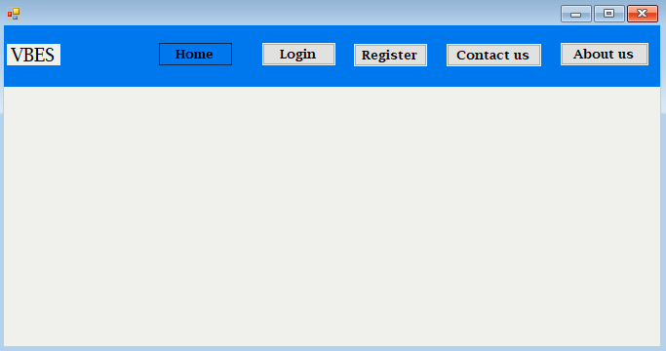

Figure 5. 6 Home page user interface

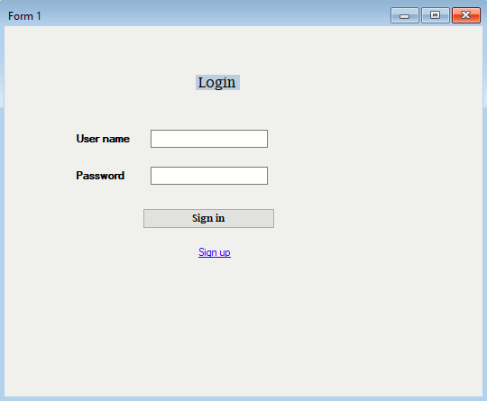

Figure 5. 7 Login user interface

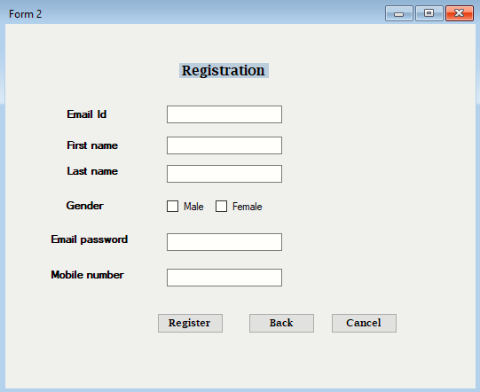

Figure 5. 8 Registration user interface

References

[1] Jagtap Nilesh, Pawan Alai, Chavhan Swapnil and Bendre M.R." Voice-Based System in Desktop and Mobile Devices for Blind People". In International Journal of Emerging Technology and Advanced Engineering (IJETAE), 2014

[2] K. Jayachandran, P. Anbumani, “Voice-Based Email for Blind People ", IJARIT, 2017.

[3] T.shabana, A.Anam, A.Rafiya, K.Aisha, “Voice-based Email System for Blinds”, “IJARCCE”, Jan 2015.

[4] P. Ingle, Harshada Kanade, Arti Lanke, “Voice-based Email System for Blind”, “IJRSCSE”, 2016.

[5] Prof Umesh A Patil, Pranouti Patil, “A survey on voice-based mails system for physically impaired peoples”, “IJIRCCE”, Jan 2016.